Biology: Unit 1 Study Guide
(I Spy with my Assisted Eye…)

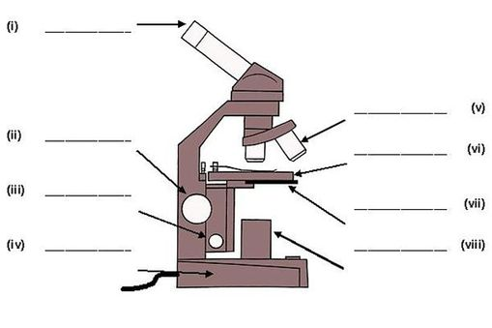
Microscope Parts and Functions
PARTS

FUNCTIONS
Focusing | Calculate magnification | Estimate size of specimen | Preparing a slide

Development of the Microscope:

Cell Organelles and Functions
ORGANELLES

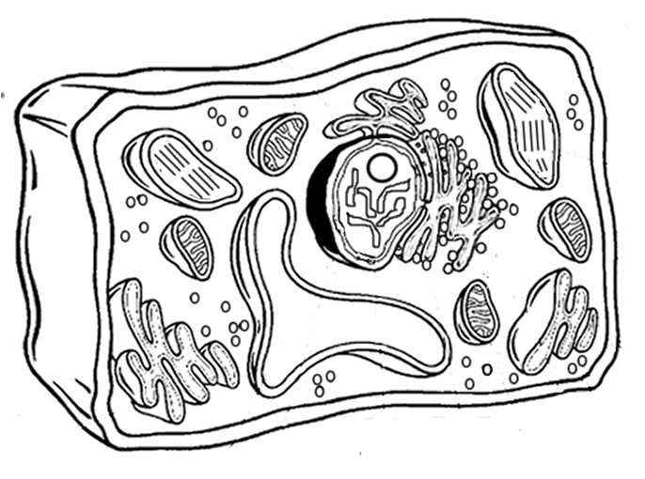
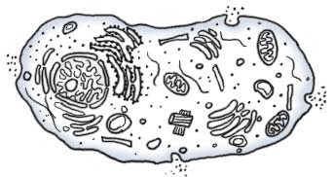

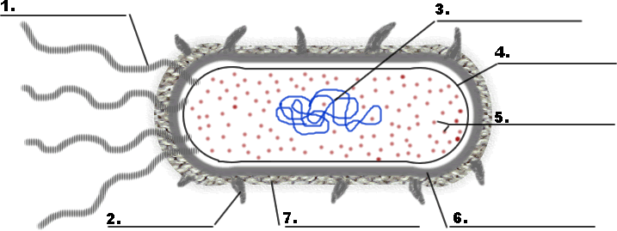

FUNCTION and structure of all organelles, with more focus on the following:
Cell Membrane | Nucleus | Mitochondrion | Chloroplast
Diffusion/Osmosis  Passive Transport  Active Transport  Facilitated Diffusion  Hypertonic, Hypotonic, and Isotonic solutions | Chromosomes/DNA  Nucleolus | Cellular Respiration | Photosynthesis

Sugar and Starch Assays

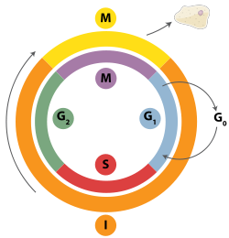
Cell Cycle
CHROMOSOME STRUCTURE LIFE CYCLE
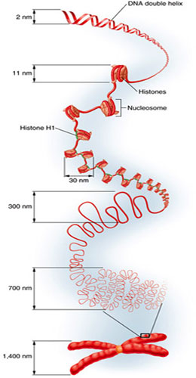

Surface Area to Volume Ratio

Cancer

MITOSIS

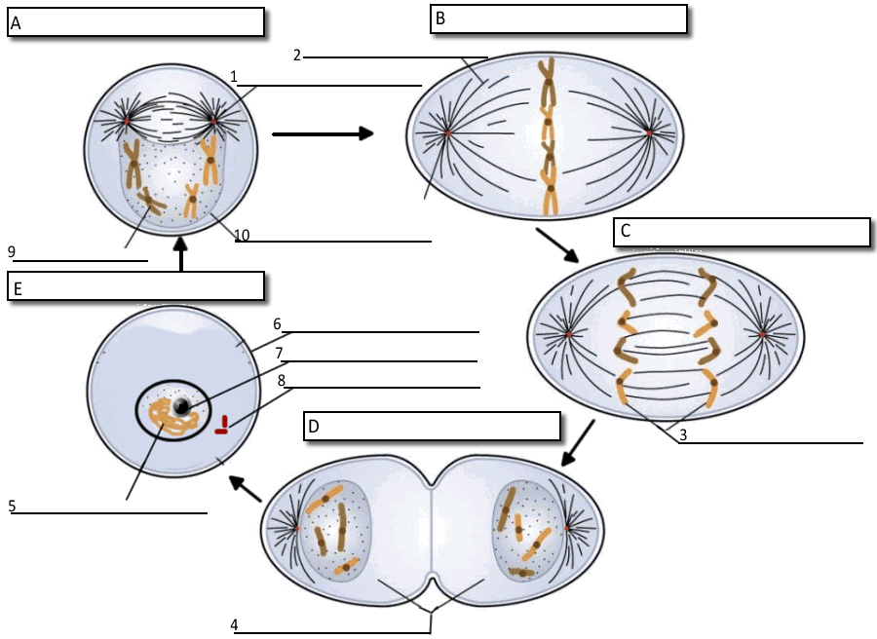

Energy in the Cell
CELLULAR RESPIRATION
Glycolosis | Citric Acid Cycle | Electron Transport Chain

Fermentation
Lactic Acid Fermentation | Alcoholic Fermentation

Photosynthesis
Light Dependent Reactions | Calvin Cycle

