# WEEBLY: Manual

The following are the current lists that have been set up. I have included SPED students with their cohorts. **Password for all cohort sites: *XXXXXX*.**

**Teacher login site: weebly.com**

**Students login site: students.weebly.com**

|  |  |
| --- | --- |
| **D-Pod** | **E-Pod** |
| DonnaClemenson (6th Girls):  Lcl 6  lclgrade6boys.weebly.com | BeccaJohnson (8th Boys):  lcl1  lclgrade8boys.weebly.com |
| CarrieCatania (6th Girls):  lcl7  lclgrade6girls.weebly.com | SigridEspe (7th Girls):  lcl2  lclgrade7girls.weebly.com |
| KatieWichtermen (6th Boys):  lcl6  (clgrade6boys.weebly.com | KatieHorecka (7th Boys)  lcl4  lclgrade7boys.weebly.com |
| Bonniealbrighta (6th Girls)  7cl7  lclgrade6girls.weebly.com | JodiScott (8th Grade Girls):  lclpanthers  lclgrade8girls.weebly.com |

# Included in this document:

## How do I monitor blog comments?

## Student forget their password!

## Need to quickly view blogs?

## Time to update your webpage?

## How do you get custom headers?

## New student?

## Want students writing comments on each other’s posts?

# Viewing/Managing Blog Comments…

All teachers can access each advisory site and moderate blogs. Click the student tab, and then the moderate blog button. Once in, teachers can approve or delete blogs. These three were deleted.

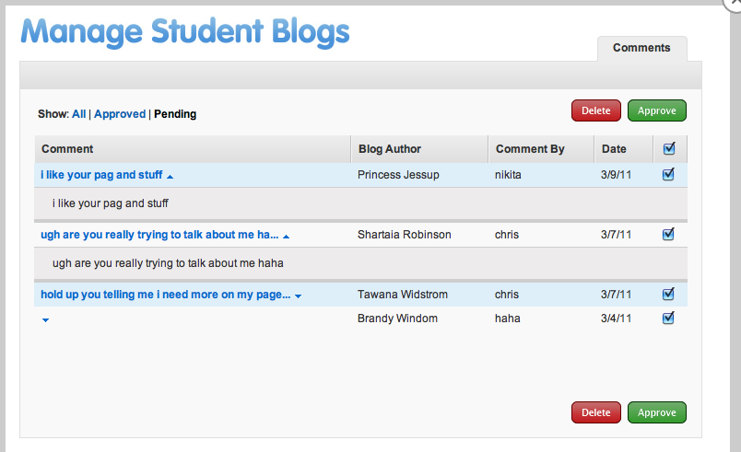

# 

# Top of Document

# Student Forgot the Password…

Not a problem. Go into the students tab, and click on the student, and you can see their password. This is also useful if a student has posted something inappropriate that you need to remove right away!

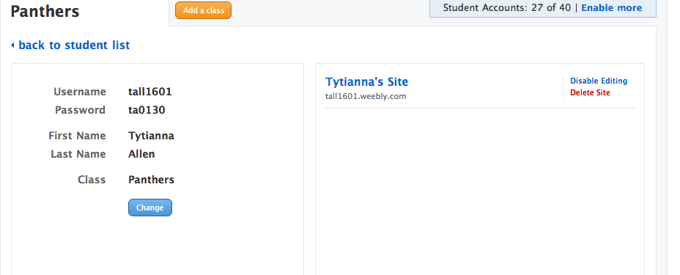

Top of Document

# Viewing Blogs… (The Quick Way)

Go into student tab, and then class settings. Temporarily turn off password protection by making student sites public, and click through student sites. Be sure to go back and make them private again.

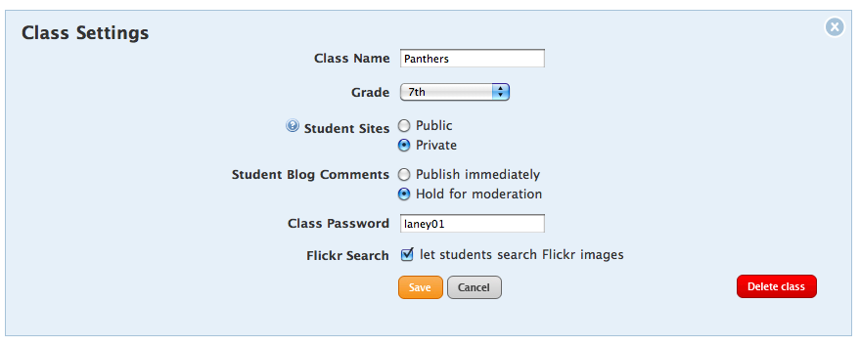

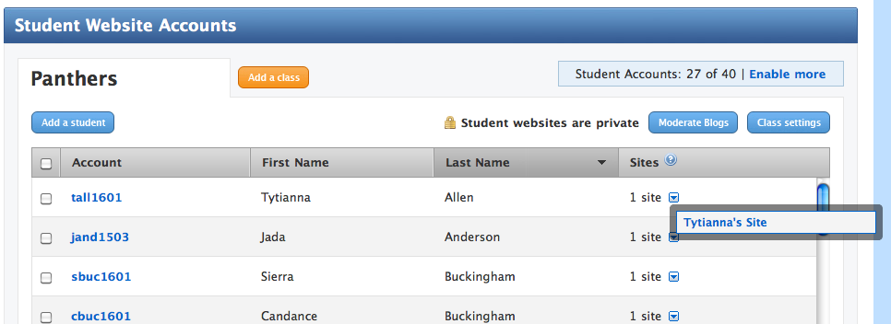

Top of Document

# The Webpage…

To edit the main webpage go to: **weebly.com**

Click on My Sites tab and edit site. From her you can modify your home page, add students to the class link list, and post your own blog!!

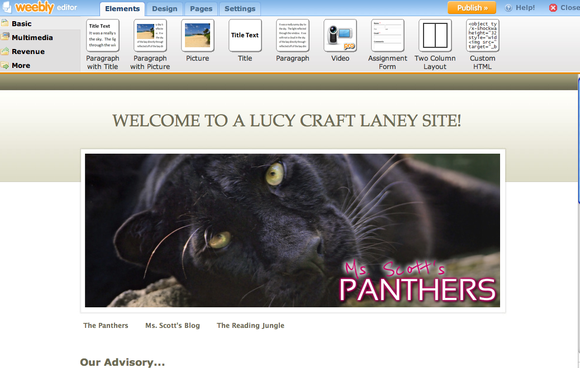

Top of Document

# 

# Custom Headers and pages…

Students only get (5) pages on their sites. So we are requesting that all students format their site to the following pages:

**Home:** A professional looking page with intro and more formal picture.

**Classes:** A page to post work, and learnings in a web page format

**Blog:** A place where students will have bi-weekly assignments

**Friends & Fun:** A place where students can express themselves in everyday ways as long as they meet appropriate expressions.



To customize headers for each page, you need to EDIT the header box, and when you save, you need to save to that page only. This will allow for the correct header for each page.

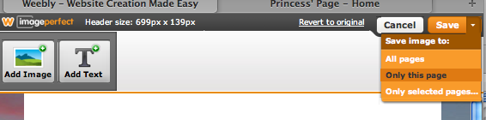

Top of Document

# New Student Set-up…

Adding a new student requires several steps. To ensure all links are good, I do this processes:

1. Go into students tab and Add a New Student. (You can have up to 40 students, so make sure to update the list and remove moved students periodically.)

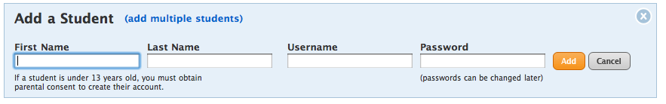

**For username, be sure to use MPLS login id.** This will also be their webpage name. The general format is: First Initial, first three letters of last name and graduation year code, then the letter ‘a’. For example, Jodi Scott who graduates in 2017 would be jsco1701a. (Be sure the code is correct, if I were the second jsco, my login would be jsco1702. Not sure… check in the gradebook).

***All students get an initial login of laney01.*** Students will go into settings upon first login to customize/privatize their login. If they forget their password, see Forgot password section.

Once this part is saved, this student has a webpage they can begin building. They will login to *students.weebly.com* to modify/blog on their site.

1. 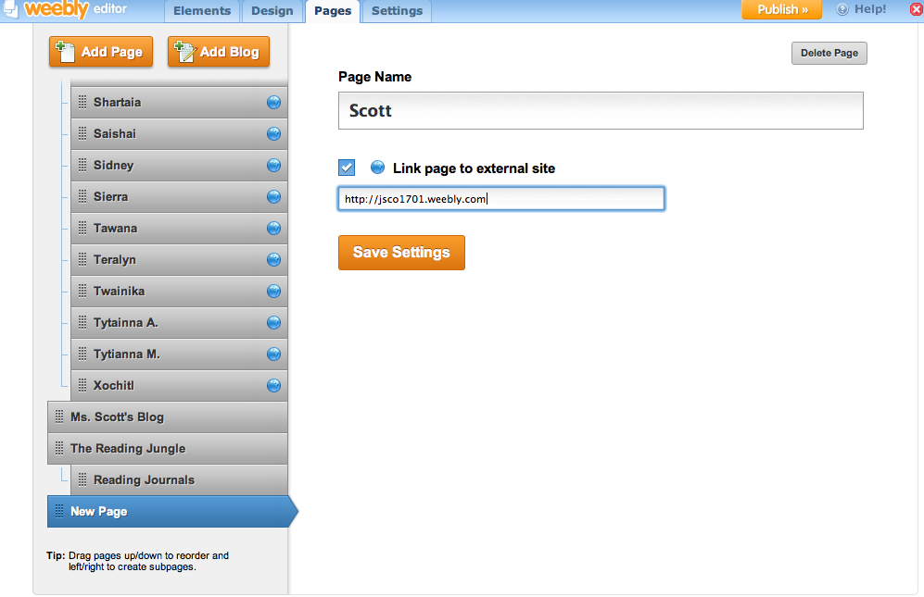Now go into the site tab, and click on the pages tab. You need to add a link to the student web page. This is done by clicking on ADD PAGE button. Give the new page the students first name, and click and drag their name to the appropriate alpha location in the advisory list.

Be sure to alpha this new page into the student list!

1. Now login to the student’s site through **students.weebly.com**

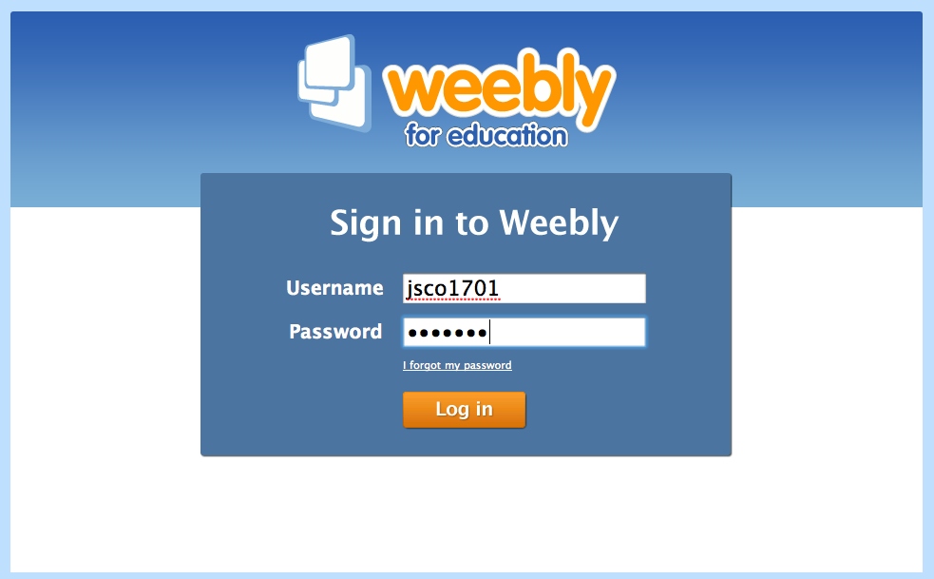

1. Immediately you will be asked to name the site. This is important because it provides the site link on the student page. Without a name, you have to visit students sites through the advisory page.

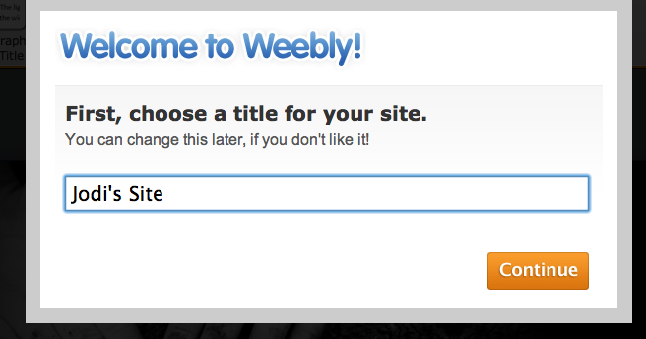

1. 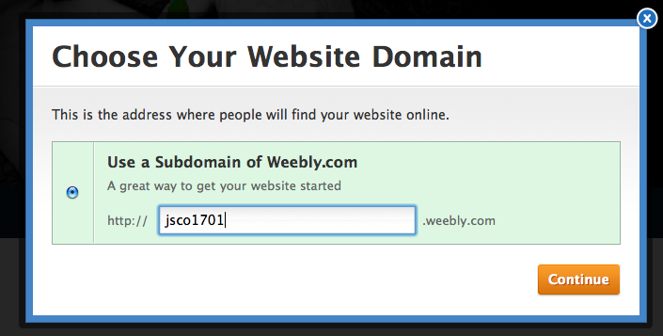At this point you can decide to add the student pages that are required, and then PUBLISH>> the page. Click on publish, and you will be prompted to name the page. The name is the same as their login ID. In my example, jsco1701.weebly.com is the site address.

**Now the student site is published and linked, and ready to go!**

Top of Document

# Student Blog Commenting…

All student sites can be accessed by other students through the advisory home page, and the **password is laney01**. This is middle school wide and I encourage all students to visit other advisory pages.



Top of Document